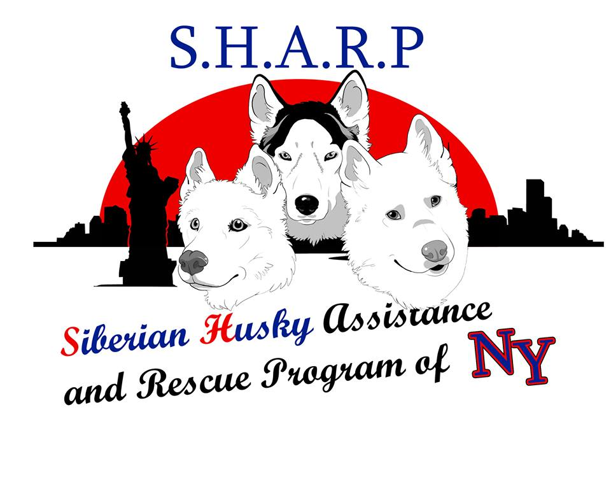

www.SHARPofNY.com

Thank you for your interest in SHARPofNY, a volunteer organization which operates a surrender, network/foster care, and educational & placement program for homeless Huskies – no matter their age, health or condition. Please print clearly.

Date:
Name(s):
(Please list all names to be included in the membership)
Address:
City: State: Zip:
E-Mail:
Phone (H): ( ) Phone (W): ( )
Do you presently own a Siberian Husky? Yes No
Do you breed Siberian Huskies? Yes No
If yes, for what purpose?
List any other animal organizations you are involved with:

How did you hear about SHARPofNY? Tell us a little bit about yourself and How you can help us help Homeless Huskies/Hours of Availblility, etc
________________________________________________________________________________________________________________________________________________________________________________________________________________________________________________________

Volunteers are needed in a variety of areas. Tell us what types of volunteer work you would like to do:
Transport Siberian Huskies (at least part way) to new homes or foster homes.
Act as a temporary foster home site for a Homeless Husky for days/week:
(please circle one)
Make follow-up phone calls to adoptive homes.
Screen potential adoptive homes.
Provide treats, food, collars, leads, etc. for Siberian Huskies in transition at foster homes.
Contribute stories/photos to our Facebook Page.
Help run and volunteer at any public events in which SHARPofNY is participating.
In consideration of this opportunity to volunteer, I agree to abide by the mission, rules, regulations, policies, and programs of SHARPofNY. while I am a volunteer.

Applicant’s Signature ______________________________________
Applicants Address________________________________________
Applicants City______________State___________Zip____________
Email Address___________________________________________
Home Phone_______________________Cell Phone______________
Date___________________________________________________
Please return completed application to:

Siberian Husky Assistance & Rescue Program of New York
POB 1521
Rocky Point, NY 11778-1521
Or Email to” HuskyRescue@optonline.net
Contact 631-921-8738

