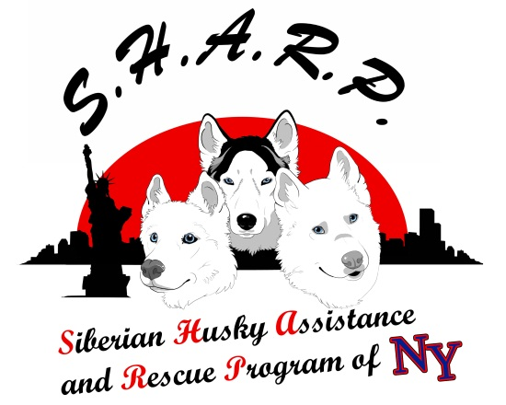
WWW.SHARPOFNY.COM

VOLUNTEER AND FOSTER CARE WAIVER OF LIABILITY AGREEMENT

I have volunteered to be a member of Siberian Husky Assistance and Rescue Program of New York . I understand that from time to time I may be called upon to transport, handle, place or provide foster care to dogs accepted into the rescue program. I understand that these dogs come from a variety of backgrounds, known or unknown, and may have temperaments, behavioral traits, or tendencies that are not known or knowable to Siberian Husky Assistance and Rescue Program of New York , or its agents, officers, directors, or members. In accepting the care, custody or control of a dog in the program, I understand that I am relying on my own judgment and experience in transporting, handling, placing or fostering the dogs, and I am not relying on any representations made by the Siberian Husky Assistance and Rescue Program of New York or its agents, directors, officers or members. I further understand that I am assuming the sole responsibility for my own safety when transporting, handling, placing or fostering dogs and I agree to the following:
• The Siberian Husky Assistance and Rescue Program of New York has made no warranties or guarantees, express or implied, with regard to the physical condition of the dog, its background or its temperament or behavior.
• The Siberian Husky Assistance and Rescue Program of New York shall not be responsible for any and all damages, costs or expense incurred by the undersigned including, but not limited to, damage or injury to the volunteer or foster care provider’s person or property by the dog, or injury or damages to a member of the family of the volunteer or foster care provider. In this connection, the undersigned releases, discharges, and holds the Siberian Husky Assistance and Rescue Program of New York , its officers, directors, and member/volunteers harmless from any and all liability of any and every nature to the undersigned’s person or property, or to the person or property of family members, caused directly or indirectly by or from the handling, transport, care or fostering of dogs within the program. The undersigned further agrees not to sue Siberian Husky Assistance and Rescue Program of New York , its officers, directors, and member/volunteers, for damages for personal injury or property damage to the undersigned and to members of their family, whether caused in whole or in part by negligent conduct by Siberian Husky Assistance and Rescue Program of New York , its officers, directors and volunteer/members.
• All foster dogs are the property of the Siberian Husky Assistance and Rescue Program of New York until such time as they are adopted. Fosters, as with any approved applicant, have the option of adopting their foster dog(s).
• Fosters must be reasonable and keep an open mind when evaluating the suitability of a potential new home for their foster dog. Not every home will be perfect, but what needs to be realized is what is best for the foster dog.

• Dogs must be made available for meet and greets with potential adopters. Foster homes will also need to contact potential adopters to discuss their foster dogs. Fosters should also make every effort to bring their foster dogs to events attended by Siberian Husky Assistance and Rescue Program of New York.
• Any aggressive behavior noted with a foster dog will need to be reported to the board immediately.

• Siberian Husky Assistance and Rescue Program of New York retains the right to visit any foster dog with advance notice given to the foster home.

___________________________ __________________________ _________
Volunteer (print) Witness (print) Date

